Request for Proposal: Persistent Person Tracking & Re-Identification from RTSP Stream (Occlusion-Resistant)

We are requesting proposals from experienced Computer Vision / AI engineers to develop a robust solution for human detection, tracking, and long-term re-identification on a live RTSP camera feed.

Project Requirements
1. Video Input
- The video source will be a live RTSP URL.
- Real-time or near real-time processing is expected.
2. Human Detection & Tracking
The system must be camera-agnostic, functioning reliably across different camera types, positions, and resolutions without dependency on a specific hardware setup
- Detect up to 10 people in the frame simultaneously.
- Assign each individual a unique, persistent ID.
- Maintain the same ID for each person as long as they remain in view.
- Handle temporary occlusions:
  - If a person walks behind another person,
  - If they become partially or fully hidden for a short duration,
The ID must not switch.
3. Long-Term Re-Identification (ReID)
If a person leaves the camera view and returns minutes or hours later, the system must:
- Re-identify them,
- Restore their original ID,
- As long as they match a previously stored embedding/profile.
The retention duration (e.g., 30 minutes, 1 hour, 6 hours) must be configurable.

4. Output Requirements
For every person detected:
- Unique, stable Person ID
- Bounding Box
- Timestamp
- Outputs need to be delivered as a JSON
- Optional: confidence scores or embeddings
5. Technology & Licensing Constraints
The proposed solution must not be built on, or depend upon, any proprietary or ecosystem-restricted SDKs or frameworks, including but not limited to:
- NVIDIA DeepStream SDK
- NVIDIA Triton Inference Server
- Any vendor-locked hardware acceleration pipelines that require specific GPUs, drivers, or commercial licenses to operate
The implementation should be based on open-source, framework-agnostic components (e.g., PyTorch, TensorFlow, OpenCV, ONNX-runtime, or equivalent), ensuring:
- Portability across standard x86 and ARM systems
- Freedom to deploy on CPU-only environments or non-NVIDIA hardware
- No vendor lock-in or restrictive runtime dependencies
- Full control over deployment, modification, and future extensibility
Any use of third-party libraries must be clearly disclosed, along with their licenses, and must allow commercial use without additional runtime or per-device licensing fees.
6. Source Code Ownership & Deliverables
The successful bidder must deliver the complete, fully functional source code for the entire solution developed under this project.
This includes, but is not limited to:
- All application source code (detection, tracking, ReID, pipeline orchestration)
- Model integration code and inference logic
- Training, fine-tuning, and evaluation scripts (if applicable)
- Configuration files, environment setup files, and dependency definitions (e.g., requirements.txt, Dockerfiles if used)
- Any custom utilities, scripts, or tools required to build, run, and maintain the system
The deliverable must not rely on closed-source binaries, obfuscated code, or proprietary components that prevent full inspection, modification, or independent deployment by the Client.
All source code delivered under this project shall become the exclusive property of the Client, with unrestricted rights to:
- Modify, extend, and refactor the codebase
- Deploy the solution in any environment
- Use the code for commercial purposes without additional fees or approvals
The vendor must ensure that the delivered codebase is sufficient for an independent engineering team to build, run, and maintain the system without reliance on the vendor post-handover, except where explicitly agreed under a separate support contract.
7. Possible Challenges
The model will be deployed in commercial kitchen environments where multiple individuals are present simultaneously, often wearing similar uniforms, hairnets, and protective gear, such as image below.
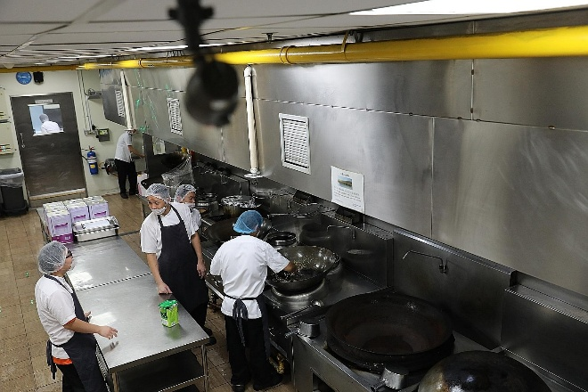 | 

These conditions create challenges such as overlapping movements, reduced visual distinction between workers, and partial occlusion due to equipment or task-specific positioning. The tracking system must therefore be optimized to maintain persistent identity assignment across frames, ensuring reliable detection and re-identification even when individuals overlap or temporarily leave the field of view. Emphasis should be placed on motion patterns, spatial context, and multi-camera coverage to achieve robust identity tracking in real-world kitchen operations.
8. Use Case
Once accurate person detection and persistent ID assignment have been established, we intend to extend the pipeline in a subsequent project to include identification of personal protective equipment (PPE) such as hairnets, gloves, and uniforms. From each person detection, the system will evaluate PPE compliance and log any violations. These violation records must be maintained consistently without duplication or overlap, ensuring that each individual’s compliance status is tracked against their persistent ID. This approach guarantees reliable monitoring of PPE usage in crowded kitchen environments and prevents redundant or conflicting violation entries

